Map related basic program :
https://javaconceptoftheday.com/java-hashmap-programs-and-examples/
import java.util.*;
class Main {
public static void main(String[] args) {
Map<Integer,String> stMap = new HashMap<>();
stMap.put(111,"Ankur");
stMap.put(112,"Mohan");
stMap.put(113,"Suyrea");
// stMap.forEach((key,value)-> System.out.println(key+":"+value));

Map<Integer,String> atMap = new HashMap<>();
atMap.put(114,"Paresh");
atMap.put(115,"Akshay");
atMap.put(116,"Bhuvan");
atMap.put(118,null);
atMap.put(120,"Pranav");
//Inserting all mappings of studentIdNameMap into anotherStudentIdNameMap using putAll() method
atMap.putAll(stMap);
//Inserting key-value pair into anotherStudentIdNameMap using putIfAbsent() method
atMap.putIfAbsent(130,"Om");
atMap.putIfAbsent(120,"Jai");
atMap.put(118,"Jagdish");
atMap.forEach((key,value)-> System.out.println(key+":"+value));
}
Output :
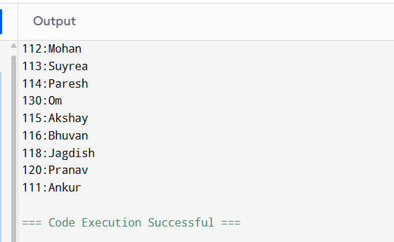
How do you check whether given key or value exist in a HashMap?
containsKey() method is used to check whether given key exist in a HashMap and containsValue() method is used to check presence of given value in a HashMap.
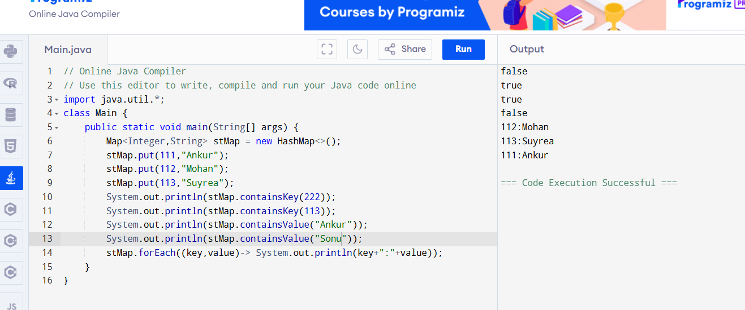
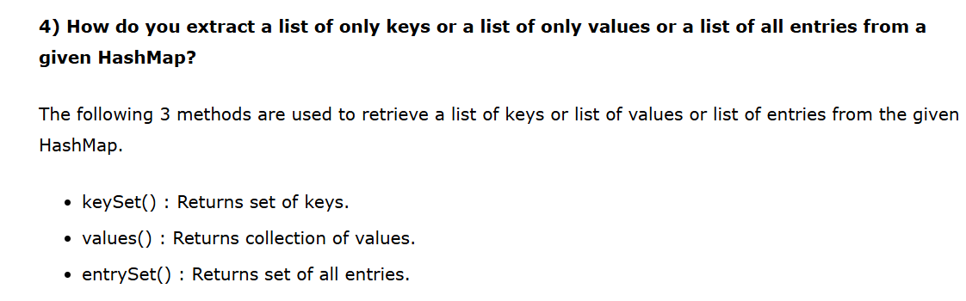
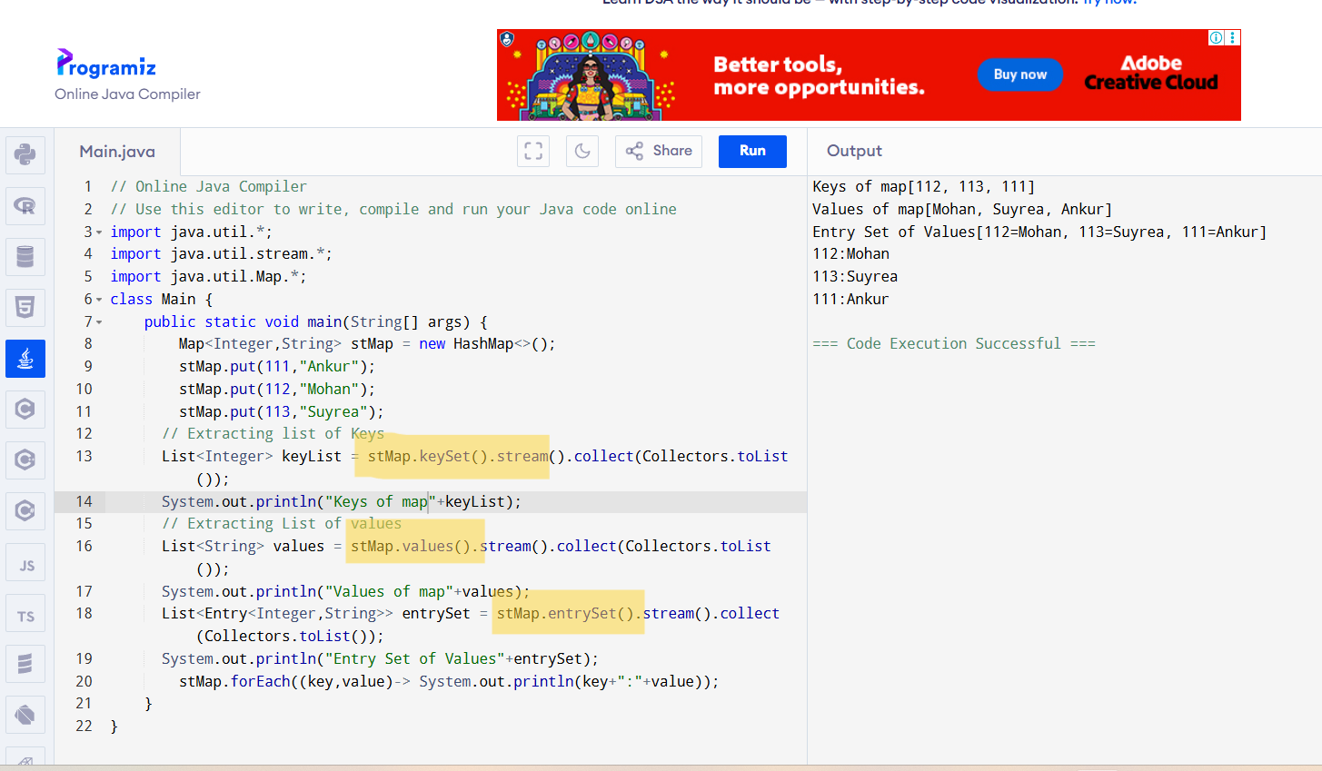
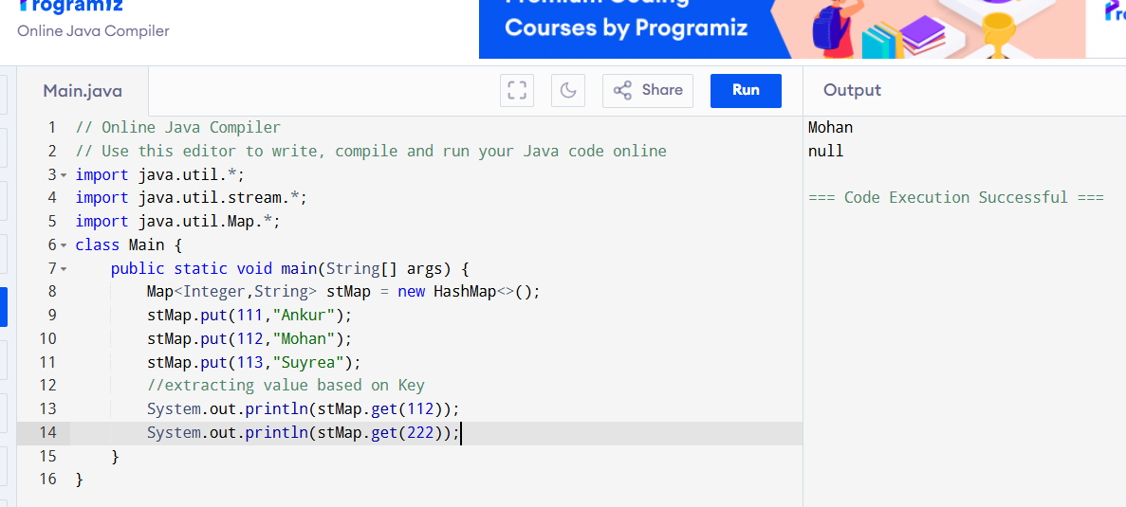
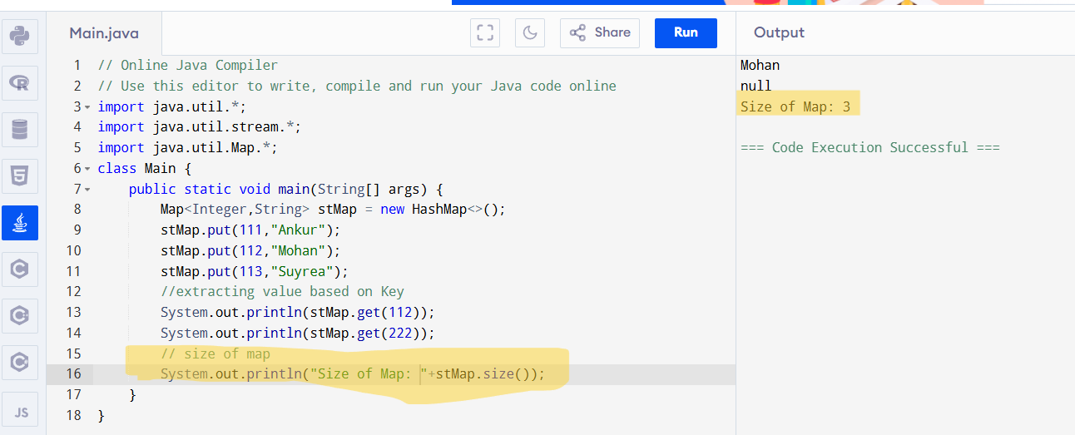
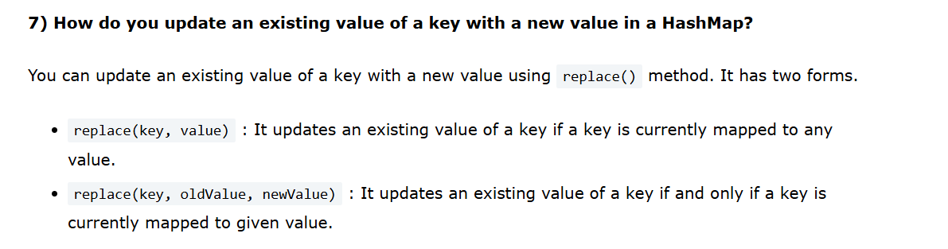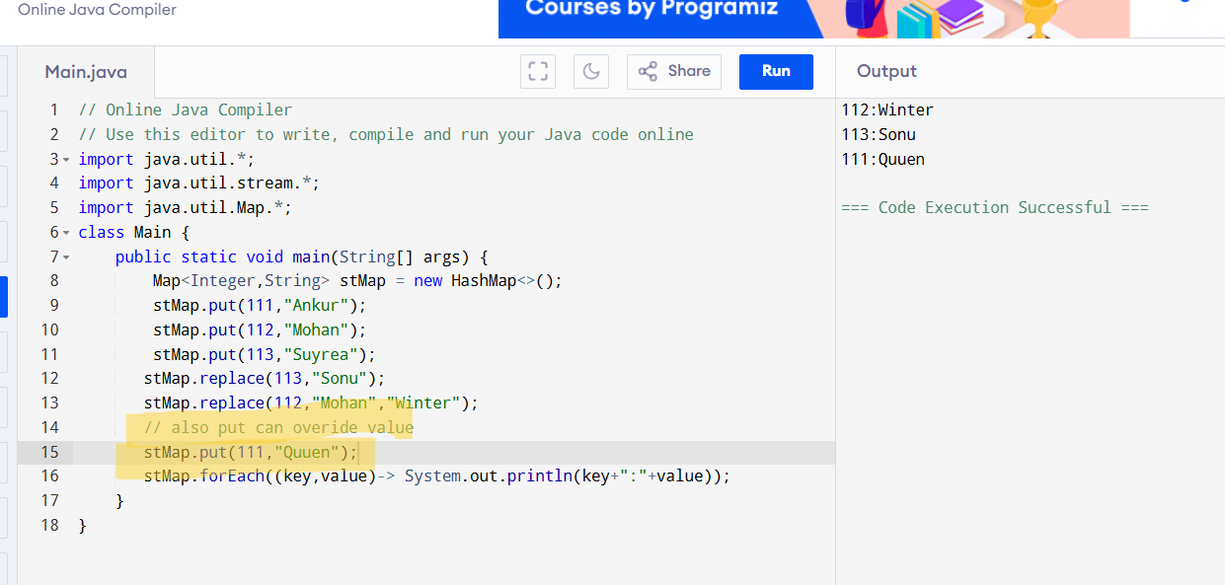
ReplaceAll : replace in bulk
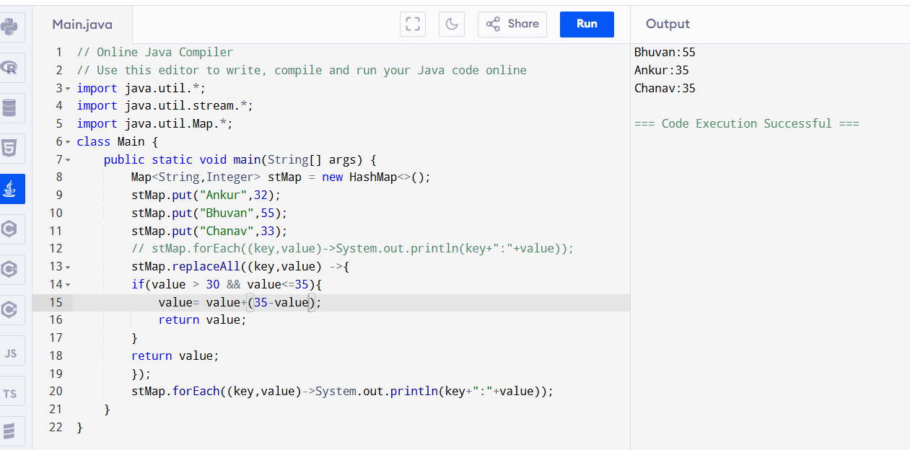
map.clear() : remove all entries from map
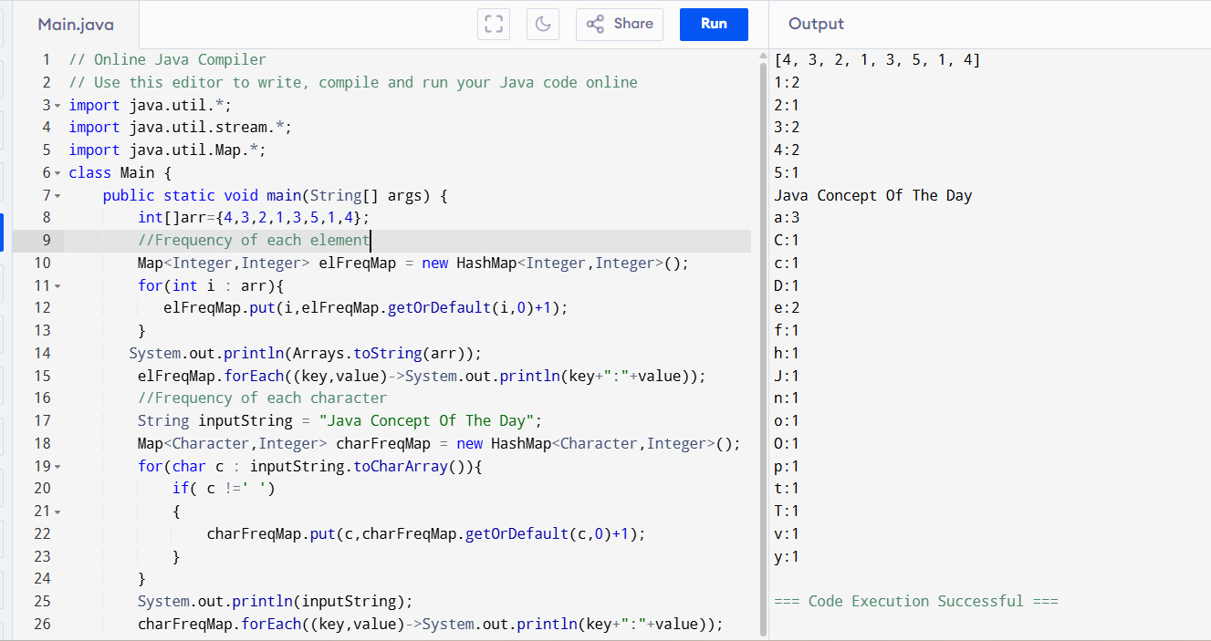
Most Frequent Second Most Frequent , top 3 most freq
import java.util.Arrays;
import java.util.Comparator;
import java.util.HashMap;
import java.util.Map;
import java.util.Optional;

public class JavaHashMapProgram
{
public static void main(String[] args)
{
int[] inputArray = {4, 7, 2, 9, 1, 7, 1, 4, 7, 8};

//Creating an empty elementFrequencyMap with elements as keys and their frequency as values

HashMap<Integer, Integer> elementFrequencyMap = new HashMap<Integer, Integer>();

//Iterating each element of inputArray

for (int i : inputArray)
{
//Inserting each element of inputArray into elementFrequencyMap
//If element is already present, incrementing its count by 1

elementFrequencyMap.put(i, elementFrequencyMap.getOrDefault(i, 0) + 1);
}

//Printing inputArray

System.out.println("Input Array : "+Arrays.toString(inputArray));
System.out.println("================================");

//Most frequent element of inputArray

Optional<Map.Entry<Integer, Integer>> mostFrequentElement = elementFrequencyMap.entrySet().stream().max(Map.Entry.comparingByValue());
System.out.println("Most Frequent Element");
System.out.println(mostFrequentElement.get().getKey()+" : "+mostFrequentElement.get().getValue());

//Second most frequent element of inputArray

System.out.println("Second Most Frequent Element");

elementFrequencyMap.entrySet().stream()
.sorted(Map.Entry.comparingByValue(Comparator.reverseOrder()))
.limit(2)
.skip(1)
.forEach(entry -> System.out.println(entry.getKey()+" : "+entry.getValue()));

//Top 3 most frequent elements of inputArray

System.out.println("Top 3 Most Frequent Elements");

elementFrequencyMap.entrySet().stream()
.sorted(Map.Entry.comparingByValue(Comparator.reverseOrder()))
.limit(3)
.forEach(entry -> System.out.println(entry.getKey()+" : "+entry.getValue()));
}
}
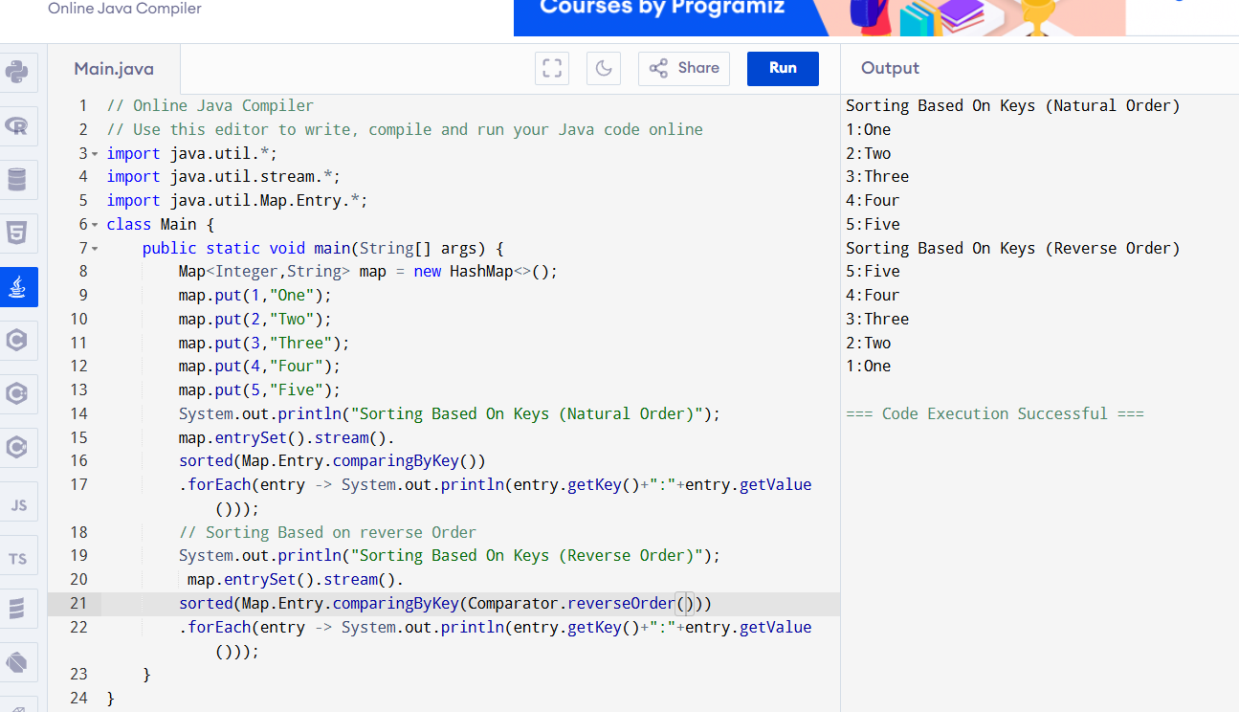
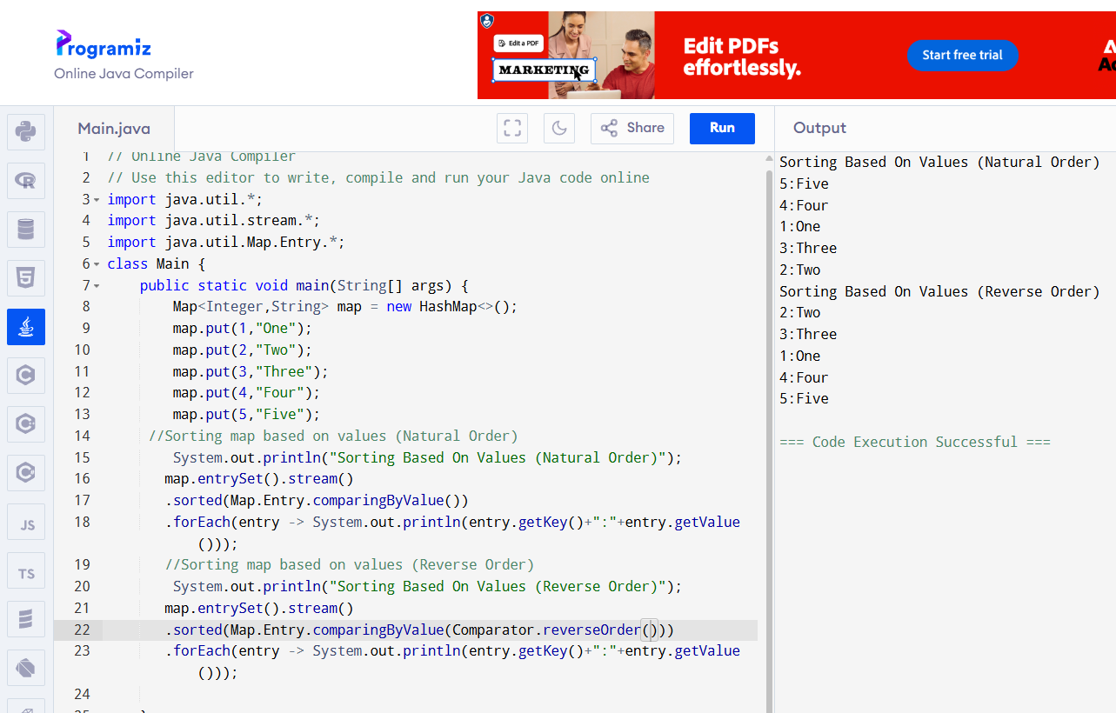
Sorting in descending order example
